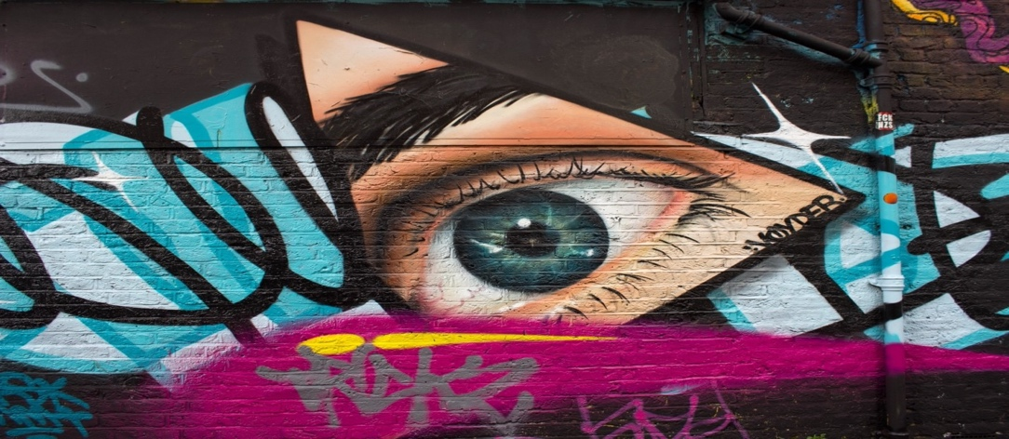

***(The Outliers)***

1. Sourav Neupane 2. Abdurakhmonova Mushtariy 3. Firdavs Bazarov

*(THE OUTLIERS)*

**Department of Computer Engineering Gachon University**

**The New-Art of Attending Students (NAAS)**

# ABSTRACT

In this digital era, face recognition system plays a vital role in almost every sector. Face recognition is one of the mostly used biometrics. It can used for security, authentication, identification, and has got many more advantages. Despite of having low accuracy when compared to iris recognition and fingerprint recognition, it is being widely used due to its contactless and non-invasive process. Furthermore, face recognition system can also be used for attendance marking in schools, colleges, offices, etc. This system aims to build a class attendance system which uses the concept of face recognition as existing manual attendance system is time consuming and cumbersome to maintain. And there may be chances of proxy attendance. Thus, the need for this system increases. This system consists of four phases- database creation, face detection, face recognition, attendance updating. Database is created by the images of the students in class. Face detection and recognition is performed using Haar-Cascade classifier and face-detection algorithm respectively. Faces are detected and recognized from live streaming video of the classroom. Attendance will be mailed to the respective student at the end of the session.

# INTRODUCTION

Traditional method of attendance marking is a tedious task in many schools and colleges. It is also an extra burden to the faculties who should mark attendance by manually calling the names of students which might take about 5 minutes of entire session. This is time consuming. There are some chances of proxy attendance. Therefore, many institutes started deploying many other techniques for recording attendance like use of Radio Frequency Identification (RFID), iris recognition, fingerprint recognition, and so on. However, these systems are queue based which might consume more time and are intrusive in nature. Face recognition has set an important biometric feature, which can be easily acquirable and is non-intrusive. Face recognition-based systems are relatively oblivious to various facial expression. Face recognition system consists of two categories: verification and face identification. Face verification is a 1:1 matching process, it compares face image against the template face images and whereas is a 1: N problems that compares a query face images [1]. The purpose of this system is to build an attendance system which is based on face recognition techniques. Here face of an individual will be considered for marking attendance. Nowadays, face recognition is gaining more popularity and has been widely used. In this project, we proposed a system which detects the faces of students from live streaming video of classroom and attendance will be marked if the detected face is found in the database. This new system will consume less time than compared to traditional methods.

EXISTING RECOGNITION SYSTEM

1. **Fingerprint based recognition system**

In the Fingerprint based existing attendance system, a portable fingerprint device needs to be configured with the students fingerprint earlier. Later either during the lecture hours or before, the student needs to record the fingerprint on the configured device to ensure their attendance for the day. The problem with this approach is that during the lecture time it may distract the attention of the students.

1. **RFID (Radio frequency identification recognition system)**

In the RFID based existing system, the student needs to carry a Radio Frequency Identity Card with them and place the ID on the card reader to record their presence for the day. The system is capable of to connect to RS232 and record the attendance to the saved database. There are possibilities for the fraudulent access may occur. Some are students may make use of other students ID to ensure their presence when the particular student is absent, or they even try to misuse it sometimes.

1. **IRIS based recognition system**

In the Iris based student attendance system, the student needs to stand in front of a camera, so that the camera will scan the Iris of the student. The scanned iris is matched with data of student stored in the database and the attendance on their presence needs be updated. This reduces the paper and pen workload of the faculty member of the institute. This also reduces the chances of proxies in the class and helps in maintaining the student records safe. It is a wireless biometric technique that solves the problem of spurious attendance and the trouble of laying the corresponding network.

1. **Face-based recognition system**

The facial recognition technology can be used in recording the attendance through a high-resolution digital camera that detects and recognizes the faces of the students and the machine compares the recognized face with students’ face images stored in the database. Once the face of the student is matched with the stored image, then the attendance is marked in attendance database for further calculation. If the captured image doesn't match with the students' face present in the database, then this image is stored as a new image onto the database. In this system, there are possibilities for the camera to not to capture the image properly or it may miss some of the students from capturing.

# PROPOSED SYSTEM

All the students of the class must register themselves by entering the required details and then their images will be captured and stored in the dataset. During each session, faces will be detected from live streaming video of classroom. The faces detected will be compared with images present in the dataset. If match found, attendance will be marked for the respective student. At the end of each session, list of presenteeism will be mailed to the respective student appeared in the session. The system architecture of the proposed system is given below:

Fig.1. System Architecture

Typically, this process can be divided into four stages,

1. **Dataset Creation**

Images of students are captured using a web cam. Multiple images of single student will be acquired with varied gestures and angles. These images undergo pre-processing. The images are cropped to obtain the Region of Interest (ROI) which will be further used in recognition process. Next step is to resize the cropped images to particular pixel position. Then these images will be converted from RGB to gray scale images. And then these images will be saved as the names of respective student in a folder

1. **Face Detection**

Face detection here is performed using Haar-Cascade Classifier with OpenCV. Haar Cascade algorithm needs to be trained to detect human faces before it can be used for face detection. This is called feature extraction. The Haar cascade training data used is an xml filehaarcascade_frontalface_default. The Haar features shown in Fig.2. will be used for feature extraction.

Fig.2.Haar Features

Here we are using detectMultiScale module from OpenCV. This is required to create a rectangle around the faces in an image. It has got three parameters to consider- scaleFactor, minNeighbors, minSize. scaleFactor is used to indicate how much an image must be reduced in each image scale. minNeighbors specifies how many neighbors each candidate rectangle must have. Higher values usually detect less faces but detects high quality in image. minSize specifies the minimum object size. By default, it is (30,30) [8]. The parameters used in this system is scaleFactor and minNeighbors with the values 1.3 and 5 respectively.

1. **Face Recognition**

The algorithm uses edge or line detection features proposed by Viola and Jones in their research paper “Rapid Object Detection using a Boosted Cascade of Simple Features” published in 2001. The algorithm is given a lot of positive images consisting of faces, and a lot of negative images not consisting of any face to train on them. The repository has the models stored in XML files, and can be read with the OpenCV methods. These include models for face detection, eye detection, upper body and lower body detection. The objective here is to find out the sum of all the image pixels lying in the darker area of the haar feature and the sum of all the image pixels lying in the lighter area of the haar feature. And then find out their difference. Now if the image has an edge separating dark pixels on the right and light pixels on the left, then the haar value will be closer to 1. That means, we say that there is an edge detected if the haar value is closer to 1. Features are applied on the images in stages. The stages in the beginning contain simpler features, in comparison to the features in a later stage which are complex, complex enough to find the nitty gritty details on the face. If the initial stage won’t detect anything on the window, then discard the window itself from the remaining process, and move on to the next window. This way a lot of processing time will be saved, as the irrelevant windows will not be processed in the majority of the stages.The second stage processing would start, only when the features in the first stage are detected in the image. The process continues like this, i.e. if one stage passes, the window is passed onto the next stage, if it fails then the window is discarded. this is how the detection of features takes place in stages. For example, when the window is at a non-face region, only the first stage with two rectangle features is running, and as they discard the window before the second stage starts. Only one window which actually contains a face, runs both the stages and detects the face.

1. **Attendance Updating**

After face recognition process, the recognized faces will be marked as present in the excel sheet and the rest will be marked as absent and the list of absentees will be mailed to the respective faculties.

1. **Sending Email**

Students who are successfully recognized, will receive an email confirming that they are present. It is done by initializing connection to our email server by using smtp library. After that, we created different functions like email lists, message, attachments etc. which is needed to fill out manually only once before implementing the use of the system.

# COMPETITIVE ANALYSIS

Authors in [3] proposed a model of an automated attendance system. The model focuses on how face recognition incorporated with Radio Frequency Identification (RFID) detect the authorized students and counts as they get in and get out form the classroom. The system keeps the authentic record of every registered student. The system also keeps the data of every student registered for a particular course in the attendance log and provides necessary information according to the need. In this paper [4], authors have designed and implemented an attendance system which uses iris biometrics. Initially, the attendees were asked to register their details along with their unique iris template. At the time of attendance, the system automatically took class attendance by capturing the eye image of each attendee, recognizing their iris, and searching for a match in the created database. The prototype was web based. In [5], authors proposed an attendance system based on facial recognition. The algorithms like Viola-Jones and Histogram of Oriented Gradients (HOG) features along with Support Vector Machine (SVM) classifier were used to implement the system. Various real time scenarios such as scaling, illumination, occlusions and pose was considered by the authors. Quantitative analysis was done based on Peak Signal to Noise Ratio (PSNR) values and was implemented in MATLAB GUI. Authors in [6] research to get best facial recognition algorithm (Eigenface and Fisher face) provided by the Open CV 2.4.8 by comparing the Receiver Operating Characteristics (ROC) curve and then implemented it in the attendance system. Based on the experiments, the ROC curve proved that Eigenface achieves better result than Fisher face. System implemented using Eigenface algorithm achieved an accuracy rate of 70% to 90%. In [7], authors proposed a method for student attendance system in classroom using face recognition technique by combining Discrete Wavelet Transforms (DWT) and Discrete Cosine Transform (DCT). These algorithms were used to extract the features of student’s face followed by applying Radial Basis Function (RBF) for classifying the facial objects. This system achieved an accuracy rate of 82%.

RESULTS AND DISCUSSIONS

The users can interact with the system using a GUI. Here users will be mainly provided with four different options such as, student id & password, email, save profile, and mark attendance & send email. The students are supposed to enter all the required details in the student registration form. After clicking on save profile button, the web cam starts automatically, and window as shown in Fig.3. pops up and starts detecting the faces in the frame. Then it automatically starts clicking photos until samples are collected. To exit, Q should be pressed. These images then will be pre-processed and stored in training images folder. The faculties are supposed to register with the respective course codes along with their email-id in the faculty registration form provided. This is important because the list of absentees will be ultimately mailed to the respective faculties.

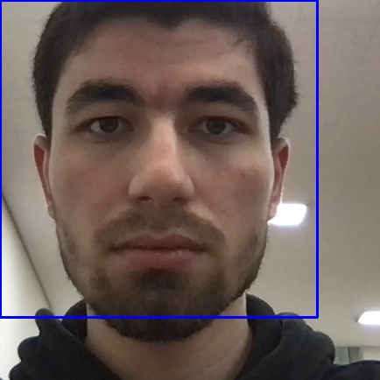

Fig.3. Face Detection

In every session, respective faculty must enter id and password, if there is a new student. Then after saving the profile, the camera will start automatically. The Fig.4. shows the face recognition window where one registered student is recognized and if in case, he was not registered it would have shown ‘unknown’. By pressing Q, the window will be closed, and attendance will be updated in the excel sheet and names of absentees will be mailed to the students individually.

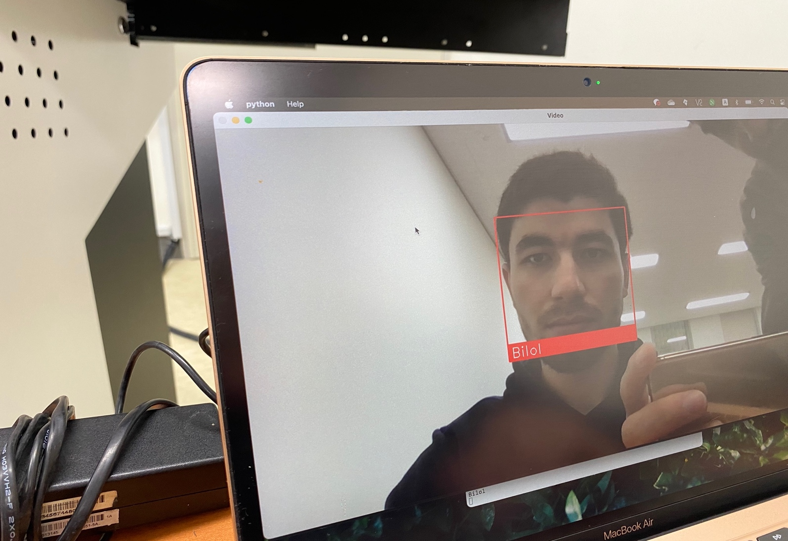

Fig.4. Face Recognition



Fig.5.Attendance Sheet

The Fig.5. shows the attendance sheet updated after recognition process. Recognized students are marked in the excel sheet with correct date and time and, notified via email whereas, the other unrecognized students(‘Unknown’) will not be registered, nor they’ll be notified.

# PRIVACY CONCERNS

As mentioned previously, we store image data on server. This approach can always raise privacy concerns, regarding the safety of those images and access level to that server. Whenever one must deal with this type of sensitive data, he must always offer means to protect data from unauthorized access. In some countries, especially in EU [4], these privacy

concerns are considered very seriously with regulations in place in their corresponding legislatures. Since this is system is mainly done to explore the advantages and the feasibility of using face recognition in attendance management, it still does not offer any privacy protection. However, if the system proves to be usable one must implement some type of secure means to ensure privacy. In password security one of the most popular approaches in this case is to encrypt data using a one-way function. For us this means to encrypt images gotten from the camera and compare those images with existing (also encrypted) images on server. However, since biometric data is noisy, this approach is not feasible. Another approach can be to use one way encryption using a private/public key approach. This way only the person in possession of the correct key can decrypt the data.

# CONCLUSION

An automatic attendance management system is a necessary tool for any Learning Management System. Most of the existing systems are time consuming and require for a semi-manual work from the teacher or students. This approach aims to solve the issues by integrating face recognition in the process. Even though this system still lacks the ability to identify each student present on class, there is still much more room for improvement. Since we implement a modular approach, we can improve different modules until we reach an acceptable detection and identification rate.

In addition, facial recognition technology offers seamless integration with a wide range of existing technologies, especially security software. The cost of integrating facial recognition into existing security solutions is minimal providing a win-win situation as individuals look to move to a frictionless solution post-COVID.

# REFERENCES

[1] https://www.researchgate.net/publication/326261079_Face_detection_ system_for_attendance_of_class’_students

[2] Hapani, Smit, et al. "Automated Attendance System Using Image Processing." 2018 Fourth International Conference on Computing Communication Control and Automation (ICCUBEA). IEEE, 2018.

[3] Akbar, Md Sajid, et al. "Face Recognition and RFID Verified Attendance System." 2018 International Conference on Computing, Electronics & Communications Engineering (iCCECE). IEEE, 2018.

[4] Okokpujie, Kennedy O., et al. "Design and implementation of a student attendance system using iris biometric recognition." 2017 International Conference on Computational Science and Computational Intelligence (CSCI). IEEE, 2017.

[5] Rathod, Hemantkumar, et al. "Automated attendance system using machine learning approach." 2017 International Conference on Nascent Technologies in Engineering (ICNTE). IEEE, 2017.

[6] Siswanto, Adrian Rhesa Septian, Anto Satriyo Nugroho, and Maulahikmah Galinium. "Implementation of face recognition algorithm for biometrics-based time attendance system." 2014 International Conference on ICT For Smart Society (ICISS). IEEE, 2014.

[7] Lukas, Samuel, et al. "Student attendance system in classroom using face recognition technique." 2016 International Conference on Information and Communication Technology Convergence (ICTC). IEEE, 2016.

[8] https://becominghuman.ai/face-detection-using-opencv-with-haarcascade-classifiers-941dbb25177

[9] https://www.superdatascience.com/blogs/opencv-face-recognition

[10] Salim, Omar Abdul Rhman, Rashidah Funke Olanrewaju, and Wasiu Adebayo Balogun. "Class attendance management system using face recognition." 2018 7th International Conference on Computer and Communication Engineering (ICCCE). IEEE, 2018.